Vanessa Hong HUGEN 2073 HW 6

Part 1
Lai et al. 2022 (https://www.nature.com/articles/s41398-022-02029-2) use 410 GWAS-nominated candidate genes for alcohol used disorder (AUD) as inputs for over-representation analysis in PANTHER's Gene List Analysis tool.

1. Re-do the PANTHER gene set analysis. You'll need to read the relevant part of the paper and look at some of the supplementary data. Use your judgment to get as close to the authors' results as possible. You should get very similar but not identical results. Download the results table (just what's significant, which should be the default setting).

2. Starting with which file/data you used and why, explain what you did in enough detail that I could replicate it without having to ask you any questions. Include parameters/options you selected.
I took the gene names from the “410 genes included in calculating PRSgene” file and pasted them into https://geneontology.org/, and performed an overrepresentation test with all default settings (using “GO biological process complete”, and reference list Homo sapiens). From there, I downloaded the table of the significant genes, imported them into a .csv file, and read it into R. I also downloaded the table “Gene ontology enrichment analysis results” and converted it into a .csv to compare these two in R.

3. Consider a gene set to be significant if FDR < 0.05.
How many gene sets were significant...
for you and Lai et al.?
for you, but not for Lai et al.?
for Lai et al., but not for you?
Lai et al. found 56 significant gene sets, and I found 89 significant gene sets. Looking at the intersection of these two data tables, there are 32 gene sets identical in both.

4. Make a figure of -log10(pyour_analysis) vs. -log10(pLai_et_al) for all the gene sets that were significant (FDR < 0.05) in both your and their analyses.
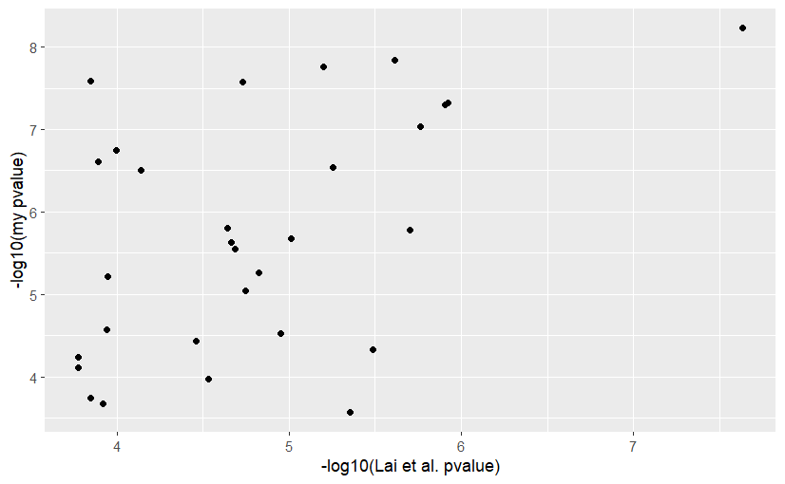

5. Assuming you used exactly the same set of PANTHER parameters and the same input list as Lai et al., what do you think could explain the differences? Hint: read the last subsection of the Methods section and your PANTHER results page very carefully.
My assumption is this has to do with different versions of PANTHER– Lai et al. uses the 2021-01-24 release of PANTHER while I am using the 2025-10-05 release. Since it has been four years between versions, the databases have likely been updated and include a lot more information, which is why I would get more results.

6. For the most significant gene set in your results, how many genes were in the gene set? List them. How many of the uploaded genes were in the gene set? Which genes were they? Try to fill in the 2x2 table representing the input for the exact test:
There were 3065 genes total and 98 genes mapped (and 53 genes expected) in the biological process of “regulation of biological quality”. These 98 gene names I have saved as a results .csv (pantherGeneList.csv) which is uploaded along with this document.
 | Genes on your list | Genes not on your list | Total
Genes with GO term annotation | 96*
Genes without GO term annotation | 2
Total | 98 | 2967 | 3065
* (When clicking the page of 98 genes, it says “Number of mapped ids found 96” which is where I have gotten this number.)

Part 2
Input the same list of genes to Enrichr (https://maayanlab.cloud/Enrichr/).

1. Are any KEGG or REACTOME pathways significant after adjusting for multiple correction? What are the most significant KEGG and REACTOME pathways?
After adjusting p-values, there are no pathways in REACTOME 2024 that pass the statistical significant threshold of 0.05. The nearest to significance of these pathways would be Ethanol Oxidation with an adjusted p-value of 0.06760 followed by Ca2+ Pathway with an adjusted p-value of 0.1124.
There are also no KEGG pathways where its adjusted p-value passes the 0.05 significance threshold. Its most significant pathways would otherwise be Circadian Rhythm, Efferocytosis, and Glutamatergic Synapse all with adjusted p-values of 0.18.

2. How do the top GO term enrichment results seem to compare with those from before? Are any Roadmap tissue/cell types enriched for ChIPseq peaks?
From Lai et al., “Of the 410 genes, 353 were uniquely mapped to the GO database… Fifty-four GOBPs had false discovery rate (FDR) P-values < 0.05, including ethanol oxidation, synaptic signaling, synapse organization, synaptic plasticity, startle response, neurogenesis, nervous system development, learning or memory, protein metabolic process, cell adhesion, cell development, cell junction organization, movement of cell or subcellular component, cell-cell signaling, regulation of signaling, etc.” Looking at the top results in the REACTOME and KEGG pathways, this is quite consistent. I do not believe there were any roadmap tissue/cell types enriched for ChIPseq peaks, or at least I could not find this information.

Part 3
White et al. 2020 (https://www.nature.com/articles/s41588-020-00741-7) performed a GWAS of normal-range facial variation. They performed GREAT analysis (http://great.stanford.edu/public/html/) on the 203 genome-wide significant associations in their data. Here you'll try to reproduce their GREAT results.

1. GREAT requires bed format input, so use Supplementary Table 3 to make a bed file containing the 203 SNPs. (Columns 2 and 3 should be identical, just the position of each SNP. Note that for X chromosome SNPs, column 1 should have "chrX".)

2. Upload the results to GREAT and run the analysis. Make sure you carefully read the notes at the top of White et al.'s GREAT results.

Download White et al.'s GREAT results(which I downloaded from a FigShare repository) to help you set the "Association rule settings" the same as White et al. (the defaults are not what you want). Be sure to use the correct species and genome build, too. After the job runs, go to Global Controls > Columns and click "Show All". Then, in the "Global Controls" bar, use the dropdown menu to select "All data as .tsv" (not just the shown data!). That will download the results as a tab-separated file.

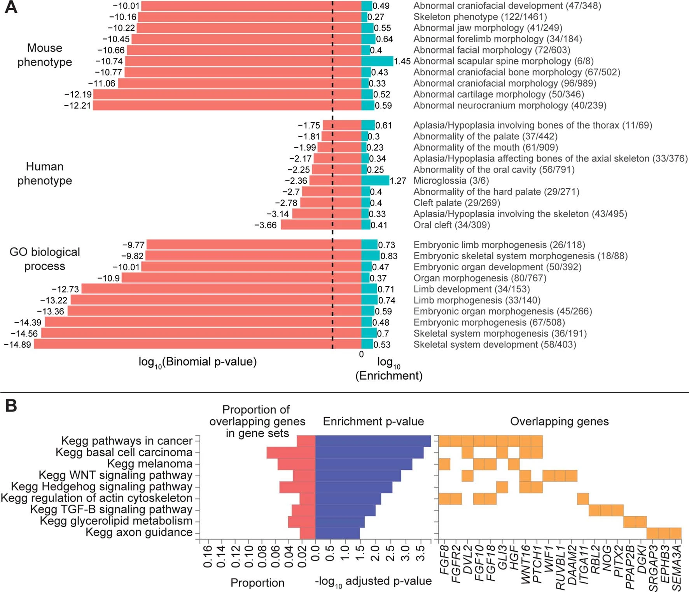

3. White et al. show some of their GREAT results in Extended Data Fig. 5a. Within each of the three annotation categories they show, focus on the two most significantly enriched annotations. For those 6 annotations, how do your results compare? Answer both in terms of significance (-log10(p)) and in terms of "Observed/Total". How similar do your results seem? Are your top results shown in Extended Data Fig. 5a? Why do you think there are differences?
The six most significantly enriched annotations in the researchers’ data:
- Mouse phenotype: Abnormal neurocranium morphology (-log10(p) = 12.19, 40/239) and Abnormal cartilage morphology (-log10(p) = 12.19, 50/346).
- Human phenotype: Oral cleft (-log10(p) = 3.66, 34/309) and Aplasia/Hypoplasia involving the skeleton (-log10(p) = 3.14, 43/495).
- GO biological process: Skeletal system development (-log10(p) = 14.89, 58/403) and Skeletal system morphogenesis (-log10(p) = 14.56, 36/191).
These all show up in my data as well, although most are no longer the top results. For me, these are my six most significantly enriched annotations:
- Mouse phenotype: Abnormal head morphology (-log10(p) = 25.33, 73/927), and Abnormal limb morphology (-log10(p) = 24.76, 63/834).
  - Abnormal neurocranium morphology is now the 8th most significant, and Abnormal cartilage morphology is now the 10th most significant.
- Human phenotype: Abnormality of the mouth (-log10(p) = 12.69, 52/936), and Abnormal morphology of the ocular adnexa (-log10(p) = 12.18, 37/608).
  - Abnormality of the mouth was the 8th most significant in Fig. 5a but is now the top most significant annotation.
  - Oral cleft now ranks quite low, although Aplasia/Hypoplasia involving the skeleton is the third most significant ranked on the table.
- GO biological process: Skeletal system development (-log10(p) = 32.36, 53/465), and Animal organ morphogenesis (-log10(p) = 27.88, 71/861).
  - Skeletal system development was is also the top result from Fig. 5a and it is even more significant now, and Skeletal system morphogenesis is now the 8th most significant.

Again, I would chalk these differences up to database updates; this paper is from five years ago and these databases have almost certainly added more information since then. Many of the top two most significant annotations are now ranked lower on their respective lists, although some have switched in position, p-value, and observed/total genes, likely also due to these annotations being updated.

